INTERNET APPLICATION

SOFT20171

REPORT

Alexandre Rodrigues

N0947973

**Introduction**

I was tasked with producing a database driven e-commerce website. The overall appearance of the website will be minimalistic and easy to navigate. The website will need to interact with a database to manage both user and product data, which will then need to be displayed. The user will have the ability to interact with both the front end and the back end if the form of a login page and admin page. Finally, some advanced features such as a basket to add items to and session handling to store the logged in users’ data.

**Appearance**

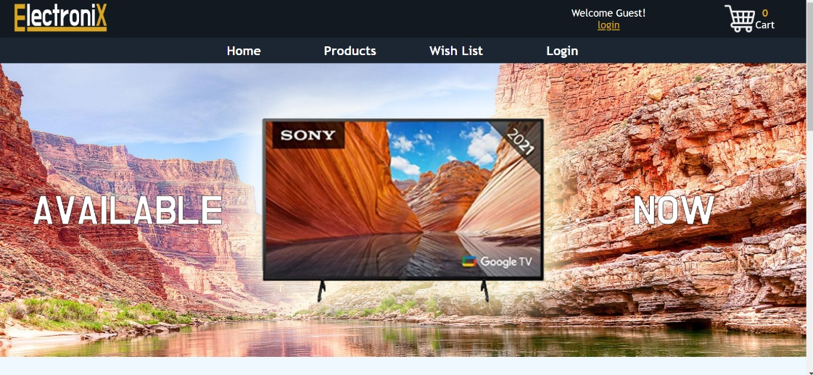When designing my website, I utilized Nielsen’s heuristics for usability as a guide to produces an easy to navigate and user-friendly website. For the colour scheme of my website, I chose the colours navy and yellow, as the navy contrasted my logo. Since I chose to go with a darker theme for my navigation bar, I made the text white so that it would easily contrast with the background and therefore it would be easy to read.

The navigation bar provides the user with the freedom to explore the webpage how they please, this follows this partially follows Nielsen 3 law “User control and freedom” (Nielsen, 1995 ), as the navigation bar appears on almost every page and can take the user anywhere . I also added a cart on the navigation bar so that it would always be visible no matter what page the user be on, I added a cart icon so that this section would be more visible and easily recognisable, this follows Nielsen 6 law “recognition rather than recall” (Nielsen, 1995), as most users are already familiar with the icon from previous interaction on different e-commerce website such as amazon and eBay.

**Database connection**

**connection**

in order to allow my website to display and interact with my database I first need to make a connection, I did this by first creating 4 variables “$host”,”$userName” “$password” and “$db”, the were then passed into the “mysqlli_connect()” function and stored in a variable called “$con”, which would then be used anytime the website would to interact with the database. To summarize, this process logs into the “phpMyAdmin” server.

Any webpage can then access the variable use using php’s include.

**Master page**

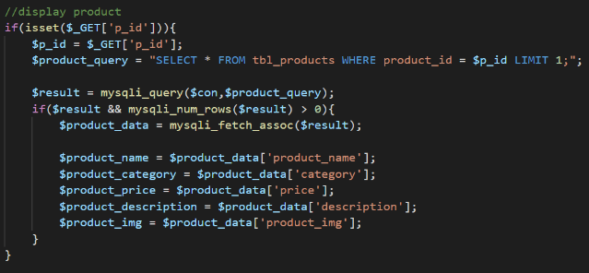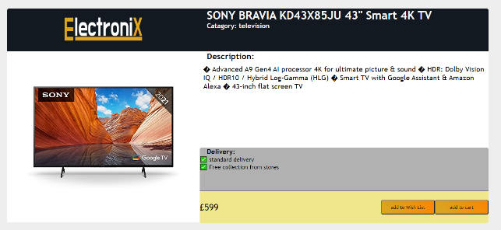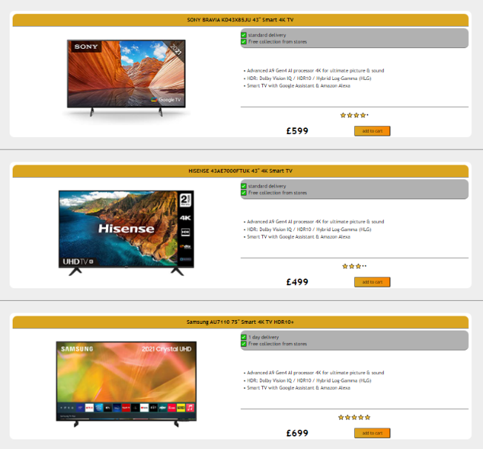When browsing, the user is able to click on the product they are interested to see it, in more detail on a new page. This dynamic page which displays the details of the product the user selected depending on what product the clicked.

First the products retrieves the product id from the URL, by first checking if the product id is set. Next, it will save the id to a variable and is use run the query using the mysqli_query() function. This will provide the contents of the id which is save to variables and then displayed on the webpage.

**User controls**

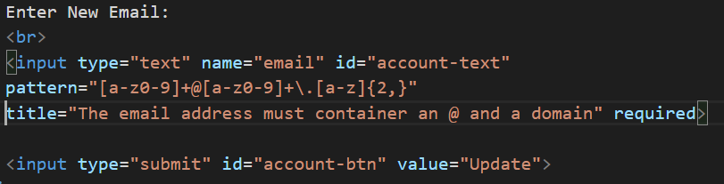**Account page**

Once logged in, the user is able to view and edit their account details in the account page. This is done by passing through the entered information into the same pages URL and concatenating it with the SQL update query :

“UPDATE tbl_login SET email = ‘$email’ WHERE id = $id” ;

In order to ensure the user enters a valid email, I included a pattern in the input tag to ensure the email contained and “@” and a “.”, this follows Nielsen 5 law “error prevention” (Nielsen, 1995).

**Admin page**

In the admin page a table of all the users and their login details is displayed. Here the admin can add, edit, and remove a user. This page is used by admin in the case a user has forgotten the password or email.

**Advanced features**

To create a cart, I first created an array to hold the cart items, this was stored in a session, as they are global and can be accessed from anywhere as long as a session is started. Then I used an if statement to check if an item should add to the array or the quantity should be incremented. To display the array in the cart page I used a foreach loop to display the data in a template I created using div which I would then echo. I need to query the database in order to display the right information in the template I created.

**Conclusion**

Overall, I believe that my e-commerce website was a success, as I was able to create a functional website which can display and modify backend data and provide the user with an easy shopping experience. My website was minimalistic with a consistent design, for aesthetic purposes. Allowing users to modify their data and admins access to everyone’s information for password handling. The feature I’m most proud is the basket, as it turned out exactly as planned, allowing users to add and removes items from the basket and have those item dynamically show up in the cart page. In a situation where I would have had more time, I would have liked to add more features to prevent SQL injection, such as more parameter to prevent the malicious inputs.

Reference:

* Cart icon: [Search results for Cart - Flaticon](https://www.flaticon.com/free-icon/shopping-cart_3144456?term=cart&page=1&position=1&page=1&position=1&related_id=3144456&origin=search)
* User icon: [Search results for User - Flaticon](https://www.flaticon.com/free-icon/user_1077114?term=user&page=1&position=3&page=1&position=3&related_id=1077114&origin=search)
* Nielson’s heuristics :(Nielsen, 1995 ),